Just as having the latest products for kids can make parenting a little easier, these cutting-edge tools for children with autism can make life easier for kids diagnosed with ASD. From books that help prepare kids for what comes next to noise reduction earmuffs in the hottest styles, discover nine must-have gadgets for kids with autism.
Little Blueprint
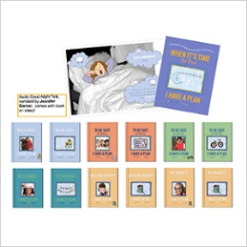
Many autistic children and kids with autistic-like behaviors thrive on routine, so when they are learning the ropes, or you're prepping them for change, Little Blueprint customized books are designed to prime kids for what's next. Available in ready-made editions or personalized with your child's picture and name, these books are geared towards "empowering kids to thrive through life's challenges and celebrations." (Little Blueprint, $38)
BuddyTag
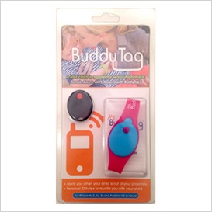
Boasted as a sanity saver for parents of kids with or without autism, the Bluetooth tracker warns parents about wandering children before they leave your designated vicinity. Worn on the wrist as a watch-style wristband, terry cloth band or Velcro wristband, the BuddyTag pairs with select smart phones via a free app to keep your child's whereabouts in check. (BuddyTag, $35)
Sensory beads
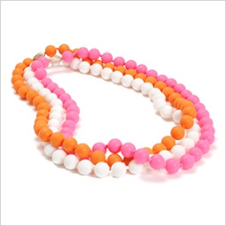
Perfect for fulfilling sensory needs, Junior Beads are crafted with your little fashionista in mind. Made by the creators of Chewbeads, the non-toxic necklaces and bracelets meet the tactile needs for kids who put everything in their mouths. (Junior Beads, $6 to $24)\\

WatchMinder3
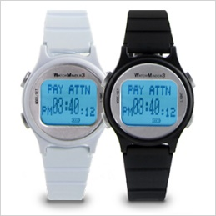
Fashioned as a sports watch and developed by a child psychologist, the WatchMinder helps kids with autism and ADHD to keep track of tasks, reinforce positive behaviors like "pay attention" and manage their medication schedule on their own. The vibrating wristwear is also discrete, making it more likely your student will be willing to wear it. (WatchMinder, $69)
iPads
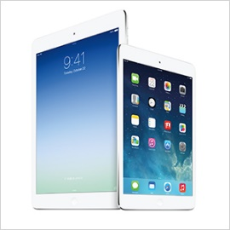
With access to a slew of apps like Brain Parade developed specifically for kids with autism spectrum disorders, iPads help children living with autism improve their motor, cognitive and communication skills. With portability and a touchscreen navigation system that traditional desktop computers cannot provide, each customizable iPad can be tailored to your child and his or her specific needs. (Apple, $300 to $800)
Sensory Pea Pod
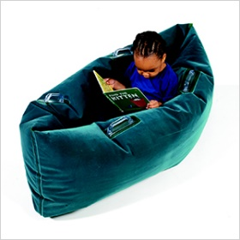
For some children on the autism spectrum, the cocooning effect of the deep, even pressure that theSensory Pea Pod offers helps calm their core and fulfill their sensory needs. Made of inflatable vinyl and flocked for comfort, the surface-washable pod is available in three sizes. (Autism Products, $89 to $114)
Giant vibrating frog
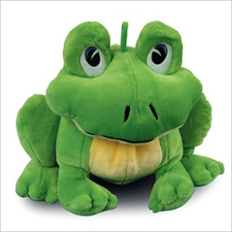
Activated by both sound and touch, vibrating toys like this giant vibrating frog encourages touch awareness, speech and stimuli input — especially for kids with special sensory needs. There are other animals available as well, such as the turtle and the love bug, which kids both with and without autism spectrum disorder will love. (Autism Products, $62)
Noise reduction earmuffs
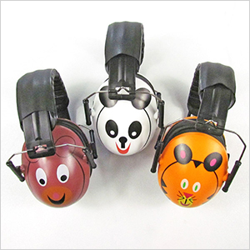
For kids with auditory sensitivity or on an ASD sensory diet, these playful animal-design noise reduction ear muffs give kids with autism shelter in a sensory storm. With an adjustable padded headband and comfortable ear cushions that nestle around the ears, the special safe design boasts a 27-decibel noise-reduction rating while still allowing children to hear conversations. (FunandFunction, $25)
SensaCalm weighted blankets
Based on the similar calming effect swaddling has for babies, weighted blankets like SensaCalm give children with autism and sensory processing disorders the calm and comfort they need to fall asleep. Made to order in the size, weight and fabric you choose, the deep pressure delivers the soothing tactile input their bodies need. Also available in weighted vests and lap pads. (SensaCalm, $70 to $200)
http://www.sheknows.com/parenting/articles/1034307/9-must-have-gadgets-for-kids-with-autism

