SNACK TIME ORAL MOTOR SENSORY ACTIVITIES FOR KIDS
The best way to give your oral sensory seeking kid the oral input they need is to provide a variety of textures and flavors at snack and meal times. Be sure to offer new foods on a regular basis. Here are some oral motor activities that can be done during snack time or meal time.
- Eat hard foods (e.g., carrots, apple, radishes, etc.)
- Eat chewy foods (e.g., celery, beef jerky, marshmallows, dried fruit, etc.)
- Eat crunchy foods (e.g., nuts, crackers, dry cereal, toast, etc.)
- Drink a frozen drink like a slush or slurpee
- Drink through a narrow and/or twisty straw
- Drink a thick liquid through a straw (e.g., milkshake, applesauce, pudding, etc.)
- Make an edible necklace with cereal or candy
- Chew gum
- Eat foods with strong flavors
- Suck on hard candies
- Eat cold foods like popsicles or ice cream
PLAY TIME ORAL MOTOR SENSORY ACTIVITIES FOR KIDS
There are lots of simple oral motor activities that you can do without specific toys. A lot of these suggestions work great for when you're in the car, waiting in line at the grocery store, in the classroom, etc.
- Blow cheeks
- Blow bubbles
- Stick out your tongue
- Blow bubbles in water using a straw
- Play straw games (e.g., use a straw to blow a pom pom across the table)
- Blow a whistle, harmonica, or other instruments
- Blow out candles
- Vibrating toothbrush
- Lick stamps
- Roll tongue into a circle
- Chew toys
- Whistle or hum a song
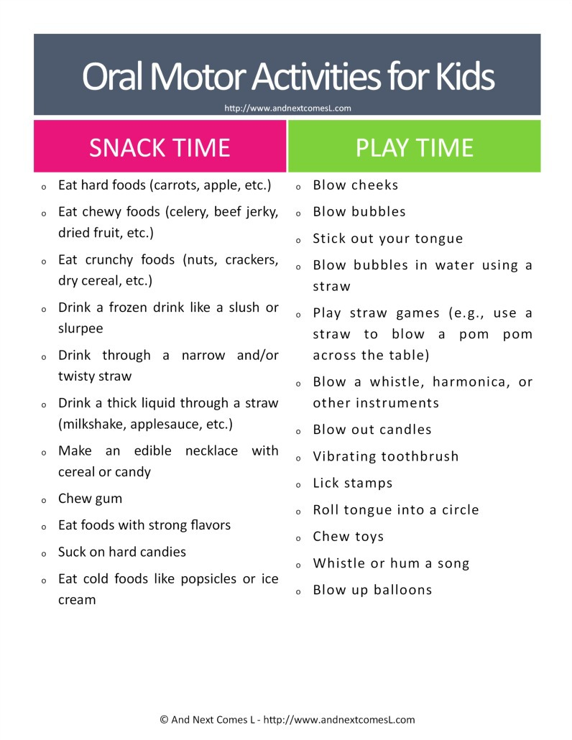
- Blow up balloons

ORAL MOTOR SENSORY TOY SUGGESTIONS
If your child is a big chewer like my son is, then you'll likely want to invest a good chew toy. I hate using that term simply because it always makes me think of dog toys, but that is essentially what these are: toys and tools to chew on. Here are some of our favorites:
Spry Natural Chewing Gum - We choose to use natural chewing gum for our kids. This gum has a great flavor and works great!
ARK Therapeutic Brick Stick Chew Necklace - I love that these come in Extra Extra Tough and can withstand more aggressive chewing.
Jellystone Robot Pendant Chewable Necklace - This robot pendant is super cute and not too clunky. I do not recommend it for excessive chewers, though, as the robot's feet can be chewed off in less than 24 hours (not that that happened or anything...)
Abilitations Integrations Chewlery Chewable Jewelry - Set of 7 Necklaces - These necklaces make great fidgets too! Highly recommend these. However, these may get caught in hair if your child has long hair.
Chewy Tubes P & Q - These are particularly great for hyperlexic kids simply because they are letters of the alphabet.
Chewy Tubes Knobby Super Chew - Love the texture on these!
Chewy Tubes - These offer lots of different textures to chew on.
Chewigem Dog Tags Chewable Necklace - Another cute chewable necklace to try.
If your kids love to chew on fabric, you could always let them chew on bandannas! Or this list of oral motor sensory toys and tools for ideas.
OTHER THINGS YOU'LL LOVE
More Oral Motor Sensory Toys & Tools
Heavy Work Activities for Kids {Free Printable}
Musical Imitation Oral Motor Game
Weekly Autism Planner {Free Printable}
Snowball Oral Motor Sensory Games

http://www.andnextcomesl.com/2015/06/oral-motor-activities-for-kids-printable.html?m=1

