It's only the second day of school and I'm wiped out! Currently, I'm procrastinating on grading phonemic awareness assessments, DIBELS and math samples. My little guys have a HUGE range of abilities this year. Looks like I'll be teaching the alphabet and numbers to one group, and long vowels and double-digit addition/subtraction to another group. And my last little genius boy will be learning social stories for reading time because he's 5 years old and read 175 words per minute already!!! So I'm using reading for an entirely different purpose for him.That's my homework tonight... to find a way to make a reading curriculum of social stories. It's an experiment. I seem to do a lot of those in my room. Special education seems to be famous for "make it up as you go" to meet the needs of amazing kids.
Ok, so today my class made perfectly clear some of their sensory needs. One kid couldn't stop making noises with his mouth, another kept covering his ears, and another accidentally wet his pants and almost cried when he told me because he said "I feel terrible that I let you down!!" as tears welled up in his eyes. There was no way I could be mad at that point. This got me thinking about all the different ways I meet those needs in my room. I know many of my followers are general ed teachers, but you may have kids with autism or Asperger's in your classroom. I thought I'd show you some super easy solutions to these problems and others.
UPDATE: Here is video I made to cover some of these topics!
I'll try to add to this list as I think of more things I use. Feel free to bookmark it or "Pin It" and it will be work in progress for sensory strategies. If you like, I can also make a direct link at the top of my page for it.
Oral Stimulation Options (Solves problems with mouth noises):
- Gum! I can't tell you how much the "no gum in class" rule seems ridiculous to me now. Teach the kids to chew quietly and throw it away properly and the annoying mouth noises stop. I've had at least a dozen different noises I've stopped with this including whistling, squeaking, and sucking sounds.
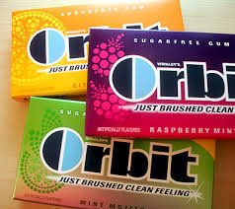
- Rubber necklaces to chew on. This works with some kids, but not all. I actually like gum better. And less germs!
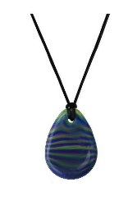
- Water bottle with rubber sucking straw
Auditory Over Stimulation (covering ears):
- Noise reducing headphones. They don't stop sound, just muffle it. Mine are red and hang on my wall using 3M Command cord hanging hooks. I'll post a pic of them on my wall tomorrow, no time for pics at school today. My new ones are red and block a bit more sound, but I my old ones that just broke were like the pic below and I liked that they folded up small.
- Quiet music, sounds counter productive, but it actually keeps the kids from talking as much and the student is no longer over stimulated by all the conversations
Bathroom troubles:
- I remind the kids to go to the bathroom during quiet work time. I realize this breaks many teacher bathroom rules, but I can remind my special little guys 800 times until I lose my voice, but that does not mean they will actually remember to go during recess. I have a bathroom in my classroom a whopping 2 feet from our work table, so it doesn't waste too much time and is significantly faster than me having to change a student's pants later.
Wiggly kids:
- Sensory cushions. These can be official wedges as you can find below, or you can also use exercise balance cushion.
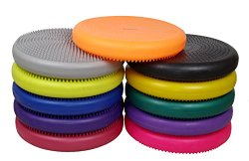
- Figits- I have squishy stars the school had made for a conference booth
- Let the student stand at their desk instead of sit. I usually put this child on the side or in the back of the class where they won't block other students view of important teaching materials
- Let the student lay on their tummy on the floor with a clipboard
- Use a weighted vest during work time
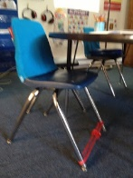
- Let the student kick their feet on an exercise band tied to their chair legs

Agitated Student:
- A designated quiet place to sit without having to ask permission when too upset to talk. I have a stairwell in my classroom that EVERY SINGLE KID uses when they get upset. I've never once assigned it, yet somehow the kids always run straight there when they get upset. I think it's quiet, no one can see them, and the walls are completely bare so there's no additional stimulation
- A weighted lap pad. I had a boy last year tell me it was like the blanket pushed the extra energy out of him. And it was only for about 5-10 minutes at a time, it didn't take too long. I only have one and it has been there for at least 3+ years. Mine actually has velcro so I've wrapped it around the student's chair before to cover their lap when their legs had too much energy. (The student liked it and it was never a "trap" or forced on him. SAFETY NOTE: Check for laws in your school, state or district, as well as get parent permission before using!
Fine Motor Struggles:
- Tracing
- Cutting
- Picking beads/Cheerios up with tweezers
- Legos
- Bead lacing
- Pencil grippers
- A rubber band to hold the pencil/crayon properly

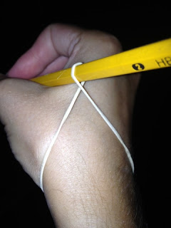
Twist rubber band around pencil and put it on the student's wrist (not too tight!!)
- Let the students type assignments instead of hand-write. I've had several students that can type at least 2 or 3 times faster than they can write with a pencil. I also have AlphaSmart so the kids can type, but there is no way for them to play games when you walk away. It only types words like a typewriter, then I plug it into my laptop to print.
- Use special scissors such as the Goldilocks Scissor from Pocket Full of Therapy
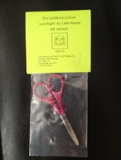

http://www.teacherlisasclass.com/2012/08/meeting-sensory-needs-for-kids-with.html?m=1

